**Setup AlwaysOn Cluster in SQL Server 2012**

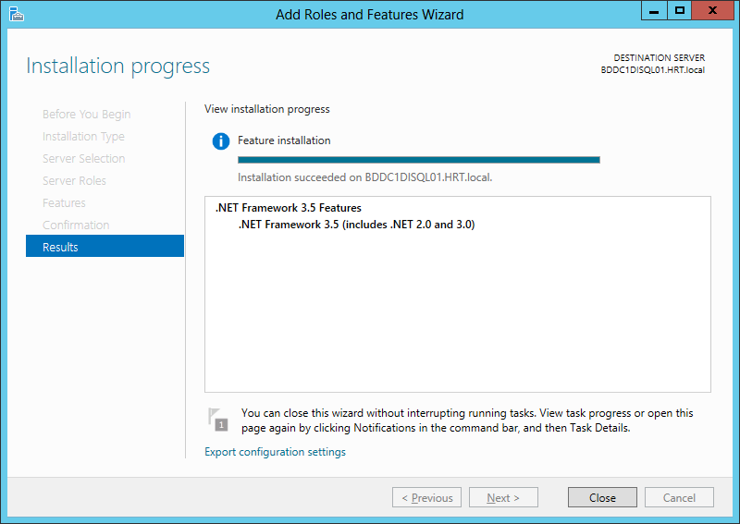

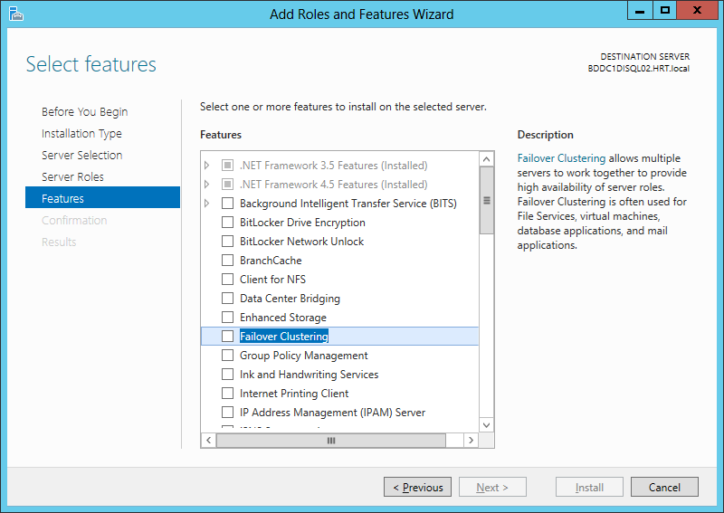

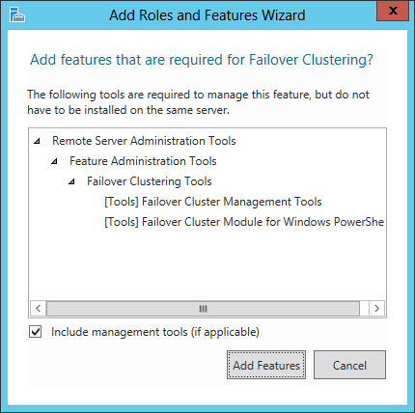

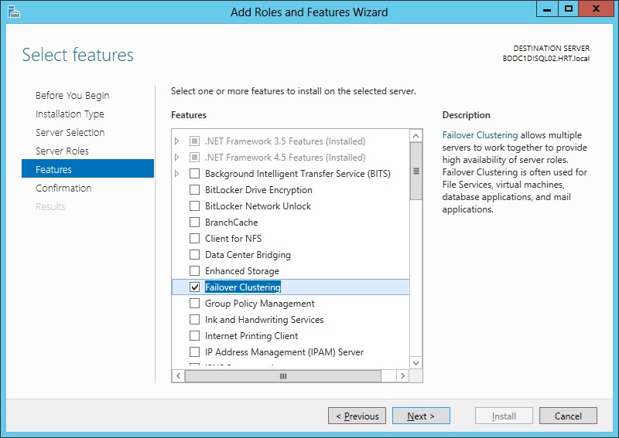



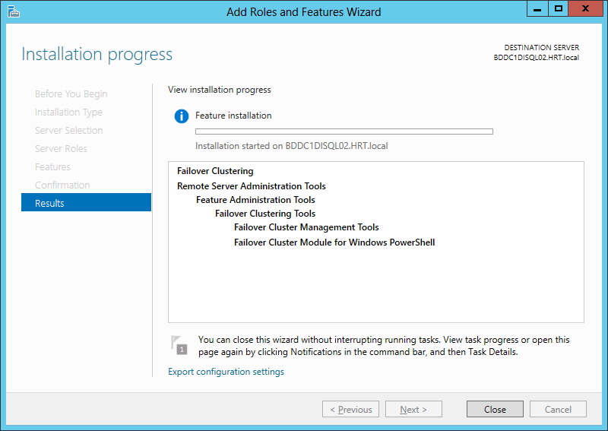

Open Failover Cluster Manager once the Failover cluster feature has been enabled.

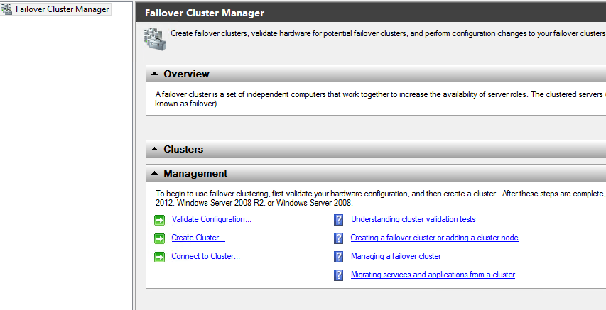

Validate the configuration to check if its suited for clustering

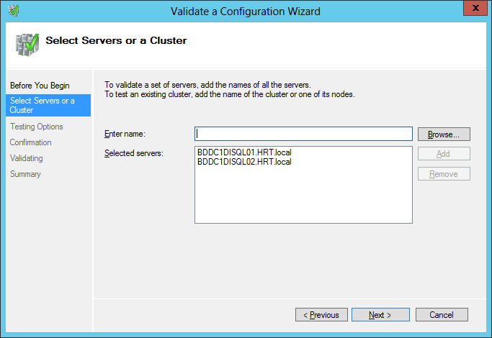

After validation is success, create the cluster

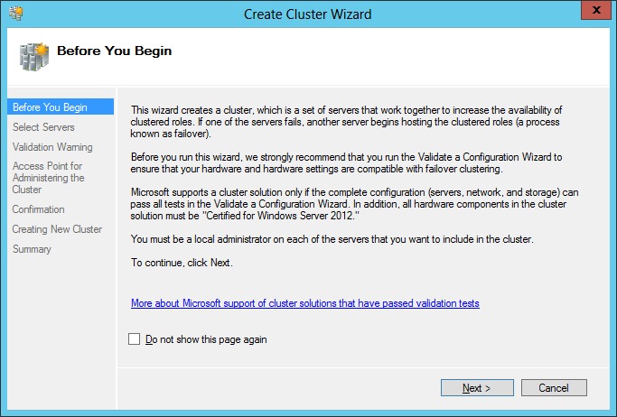

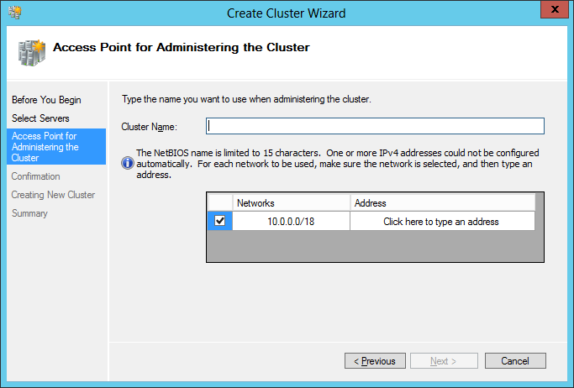

At this point, give it a cluster name like BDDC1DISQLCL01, create an object in active directory. Have Sys Admin look up a free IP and assign it to this object/cluster_name. After this, you can proceed to create the cluster

NOTE: Right now, IPs are being tracked on an excel spreadsheet.

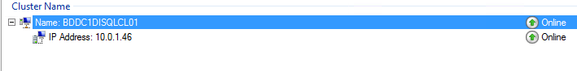

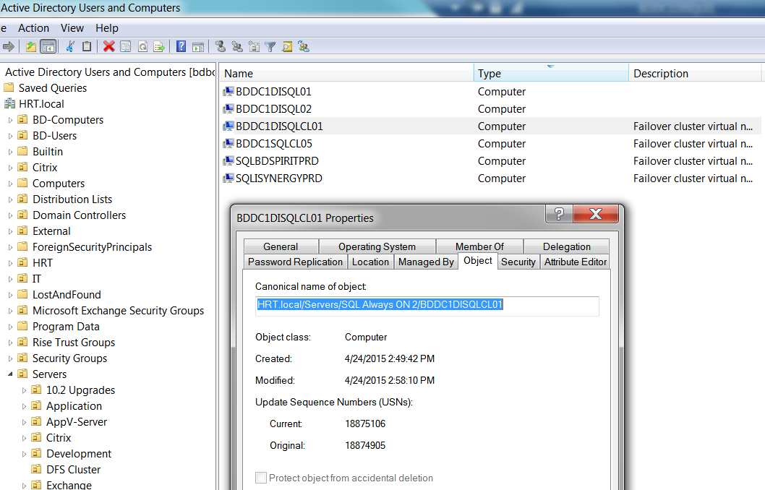

Also, create an object for AlwaysOn listener for use at later stage in the creation of AlwaysOn groups.

Reserve a free IP to use for listener configuration

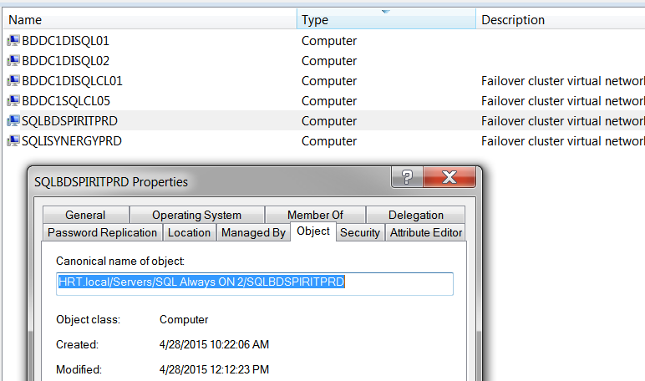

Configure Quorum on the FailOver Cluster Manager:

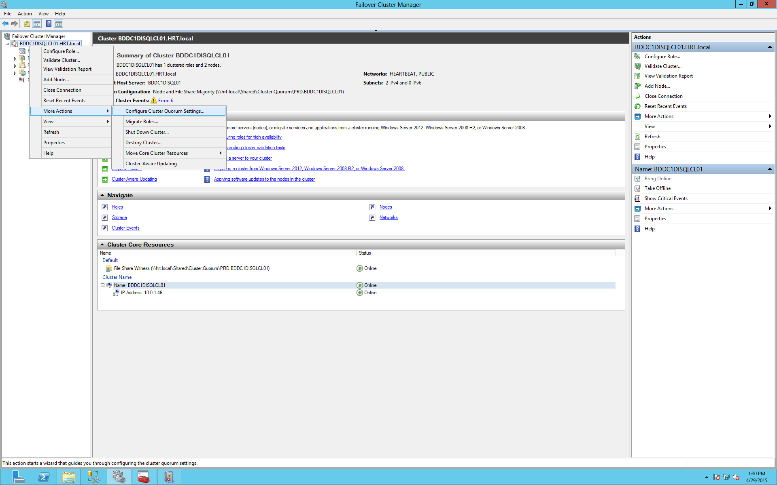

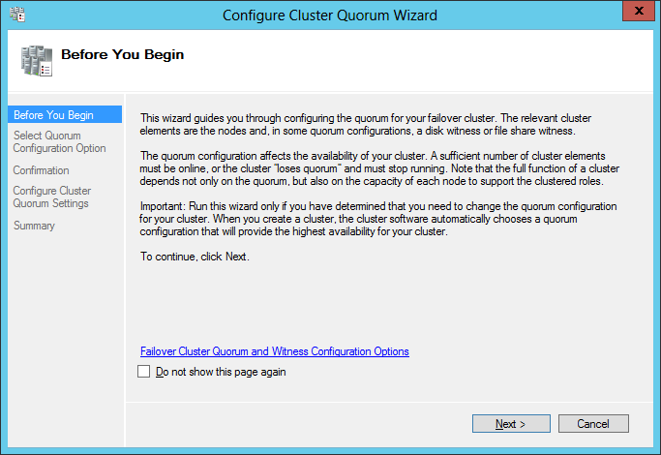

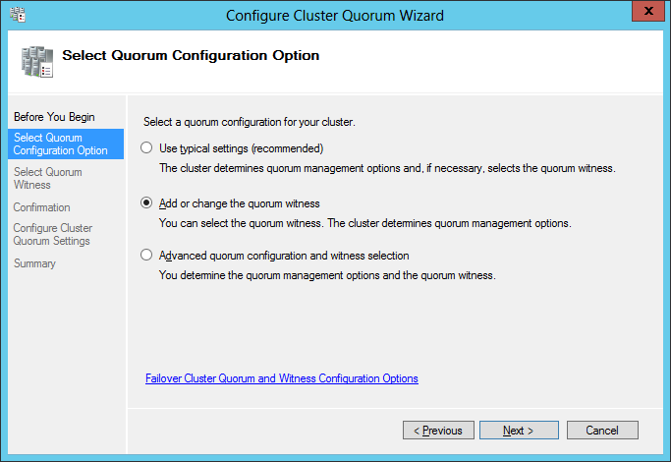

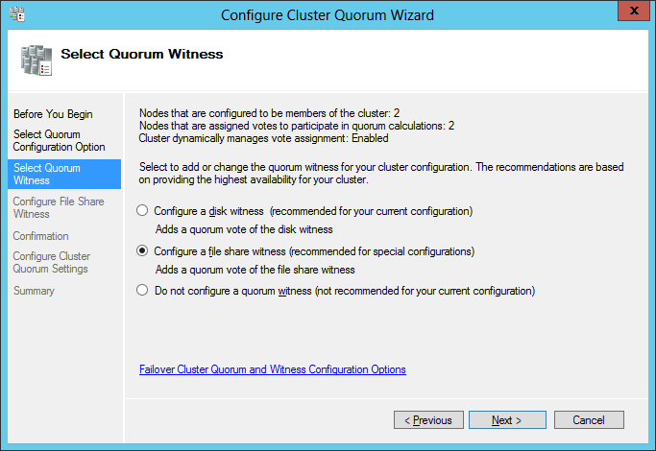

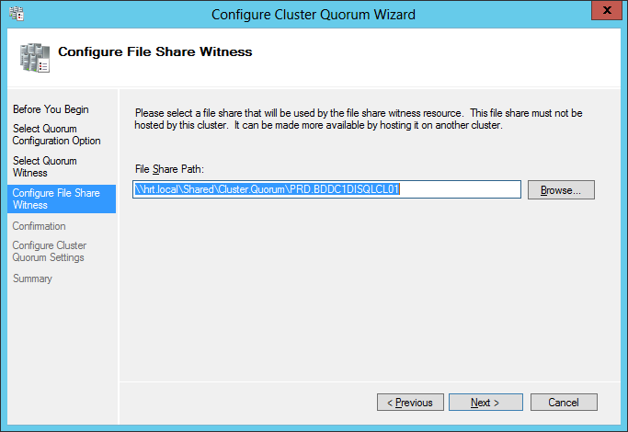

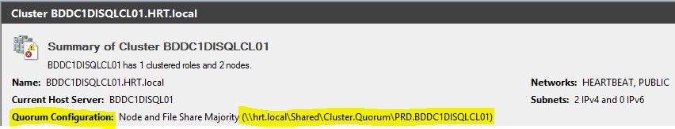

NOTE: Make sure that the server has two network cards.

Name one of it as PUBLIC and the other one as HEARTBEAT. HEARTBEAT network is for AlwaysOn Cluster usage and the public network is for the usual SQL traffic.

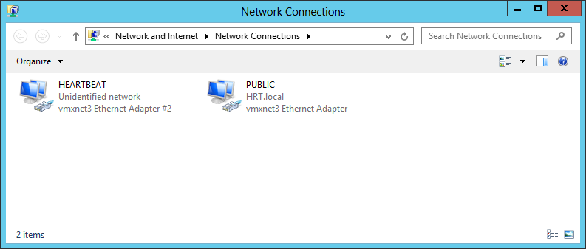

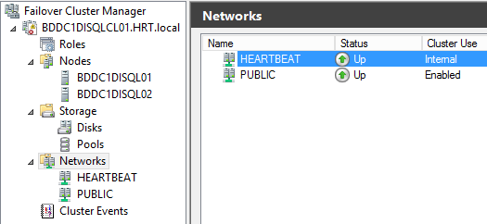

Once all the above is setup. Install SQL server if it’s not done already; Enable the AlwaysOn Feature from SQL Server Configuration Manager as shown below:

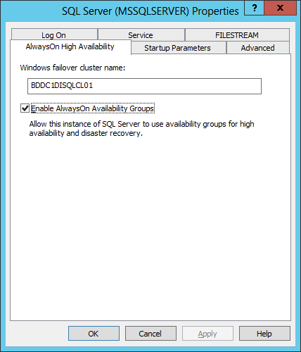

Open the Availability Group Wizard and create an Availability Group (AG)

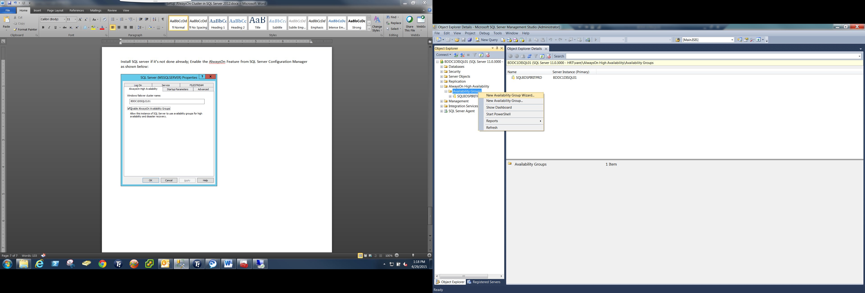

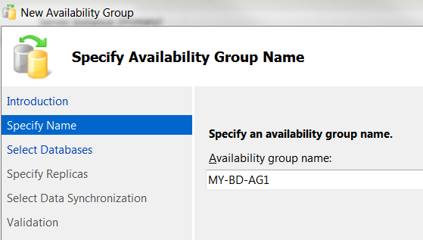

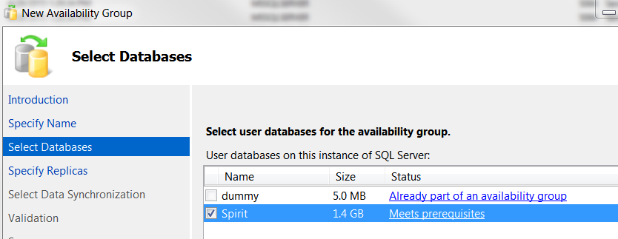

NOTE: In order to meet AG requirements, Set the recovery model to FULL and take a full backup of the database

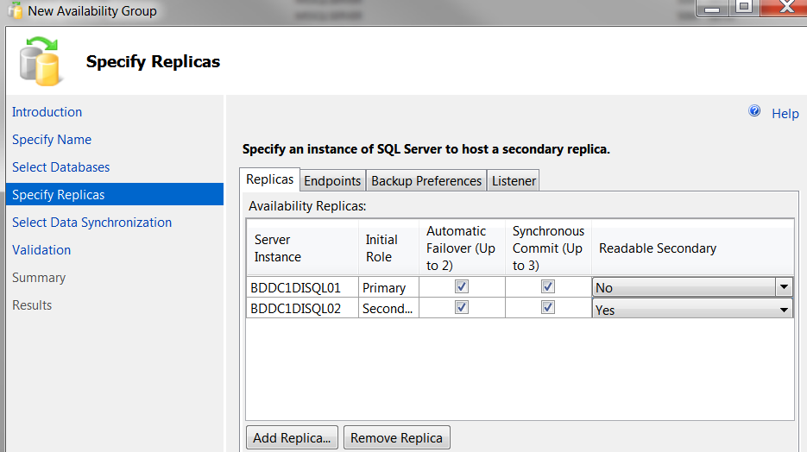

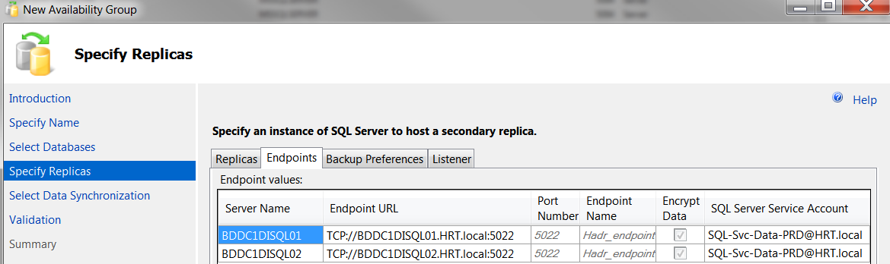

Set the backup preference to Primary in our case due to backups running from commvault

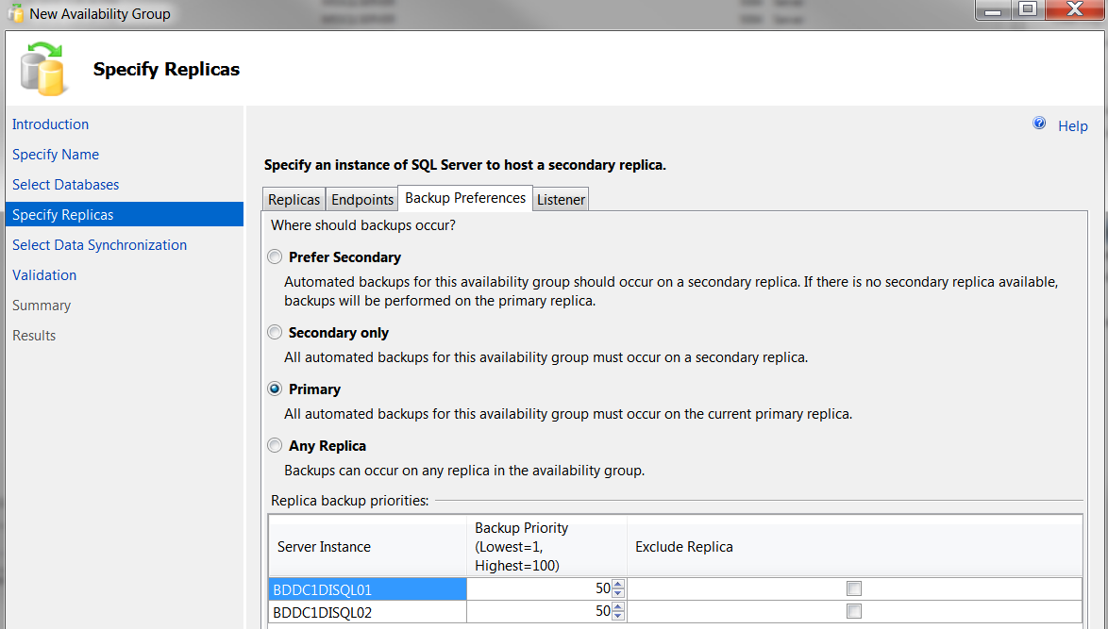

Create a listener, use the object created earlier in AD (SQLBDSPIRITPRD), usually its ok to create listener name similar to the AG name

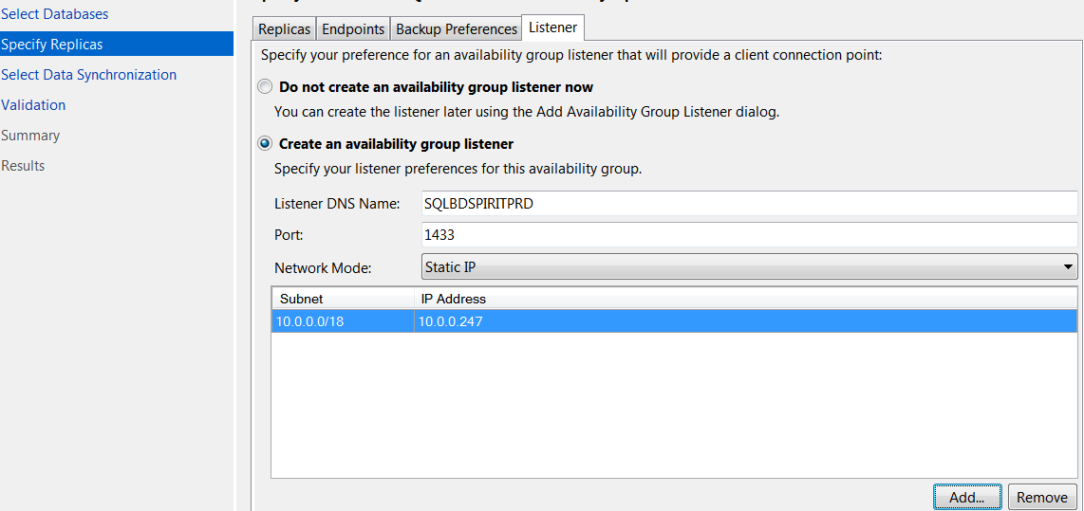

Go to next step, provide a temporary shared location for the backup and restore operations.

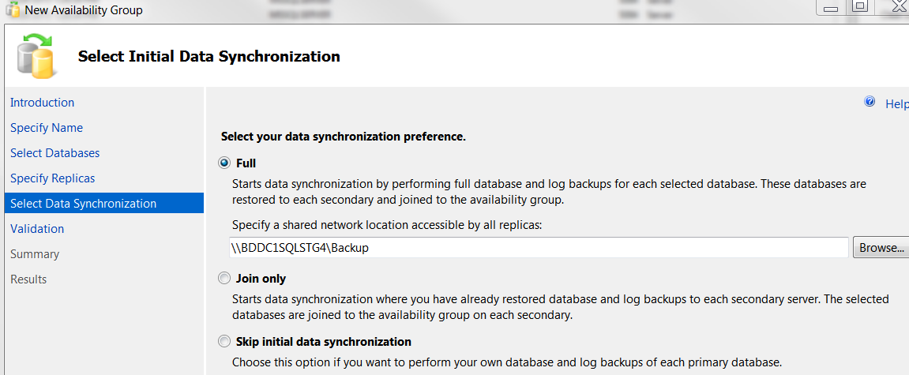

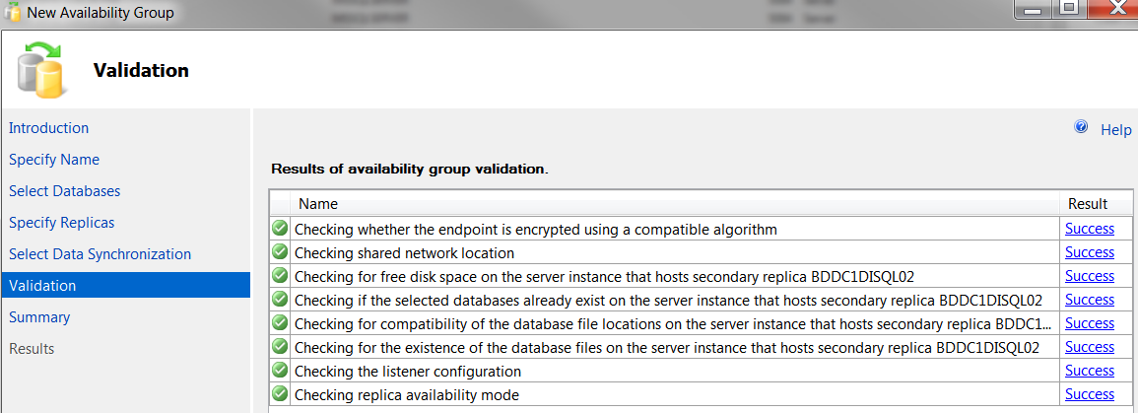

Go ahead and confirm to create the AG group and add the database to the AG group

